**Honors Computer Programming II Project Rubrics**

**VB 6.0 Projects**

**ProjectsHangman**-Create a program that will play Hangman

**“B”**

1. randomly picks word, plays game( using Mid() to break word up), cannot pick same letter more than once, 1 player

**“A”**

1.Control array, levels (1), score (1), genres for words (1), timer (1), 2 player & 1 player (1), animation (1) 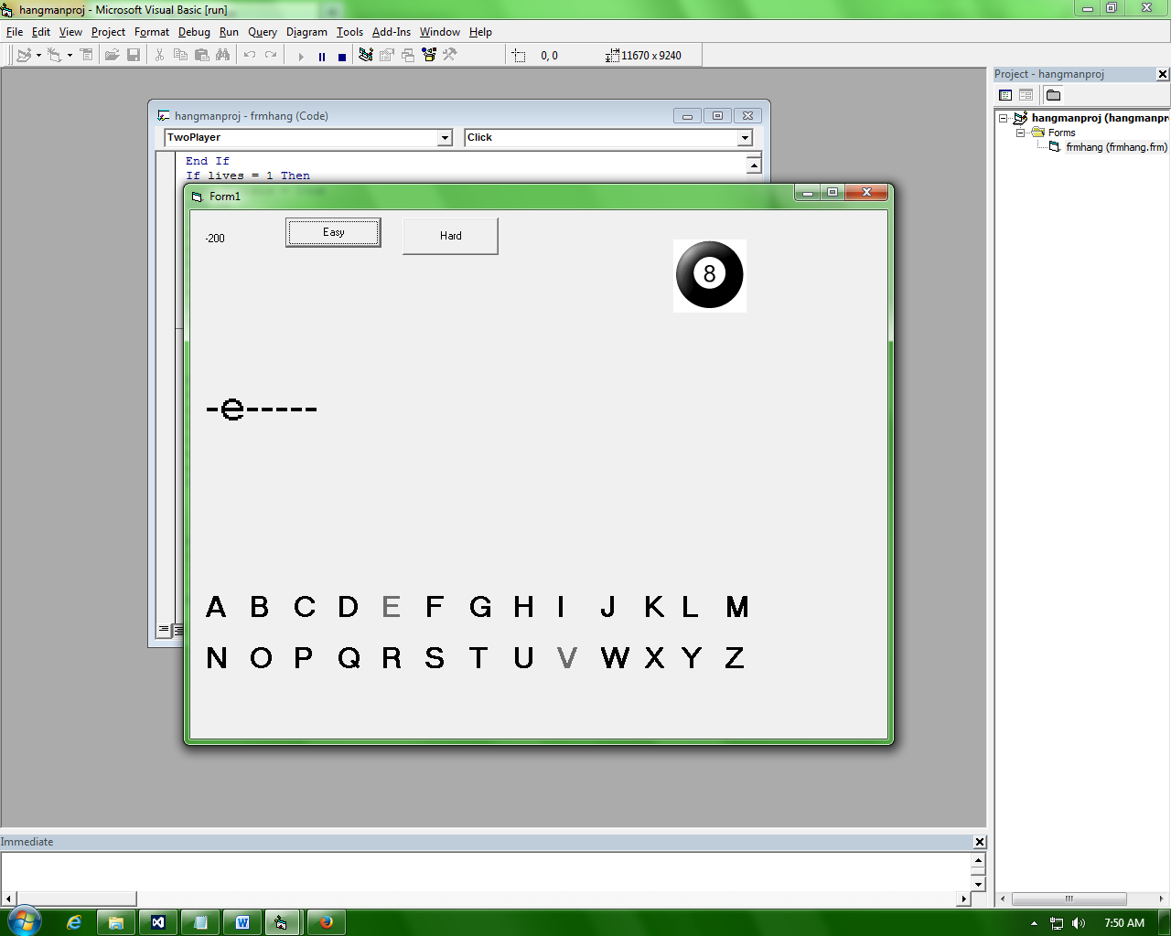

**Graphing Calculator**-Create a program that can graph a line, circle, and parabola

**“B”**

1. 3 Graphs (line, circle, parabola) only 2 graphs at a time

**“A”**

1. Both ways of Input (mouse down and textbox)
2. Extra draw types
3. Points of intersection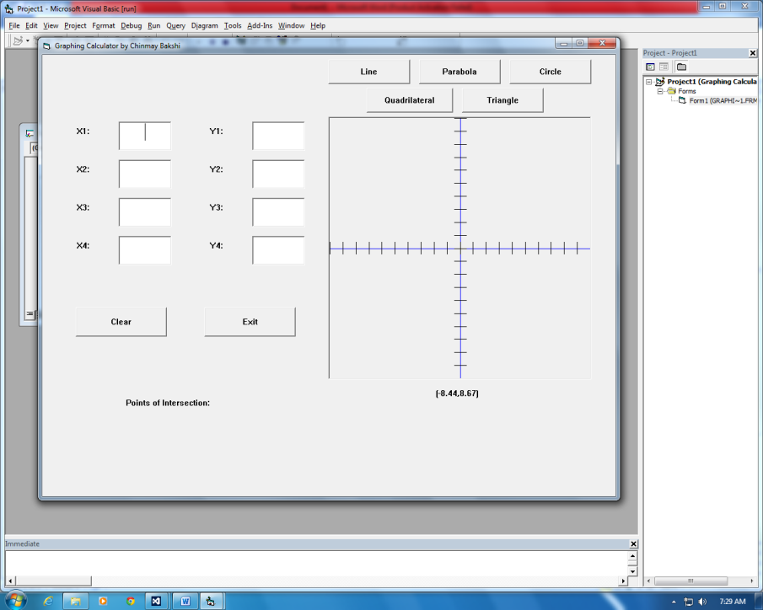

**Cafeteria**- Create a program that will random generate survey results and graph them

**“B”**

1. Randomly generate data
2. Horizontal Bar Graph
3. Labels must move w/ bar length

**“A”**

1. More graphs (Vertical Bar, Line, Piechart, …), Legends

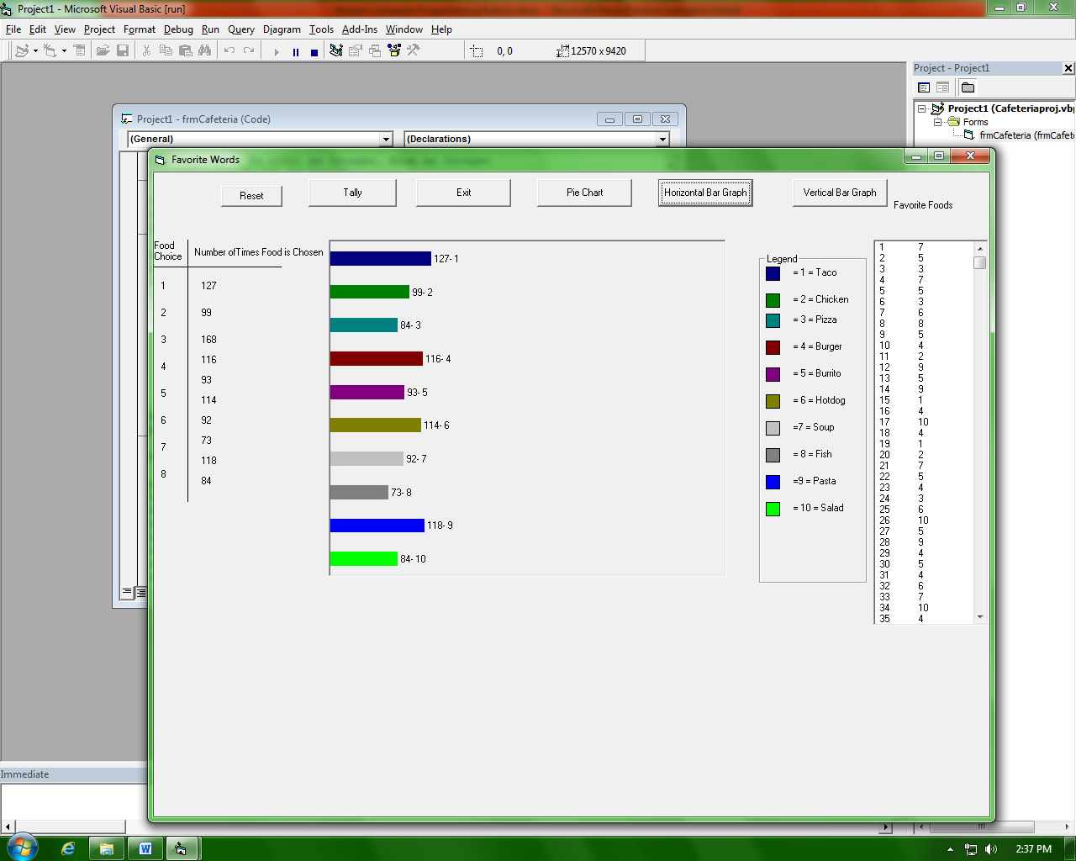

**Employee**-Create a program to manage employee data

**“B”**

1. Age, Paytype, Wage, First Name, Last Name

2. Save + Retreive

3. Add

4. View one/all

5. Multiple forms and pull-down menus

**“A”**

1. Change

2. Delete

3. More Data

4. Linear Searches

5. 12.5

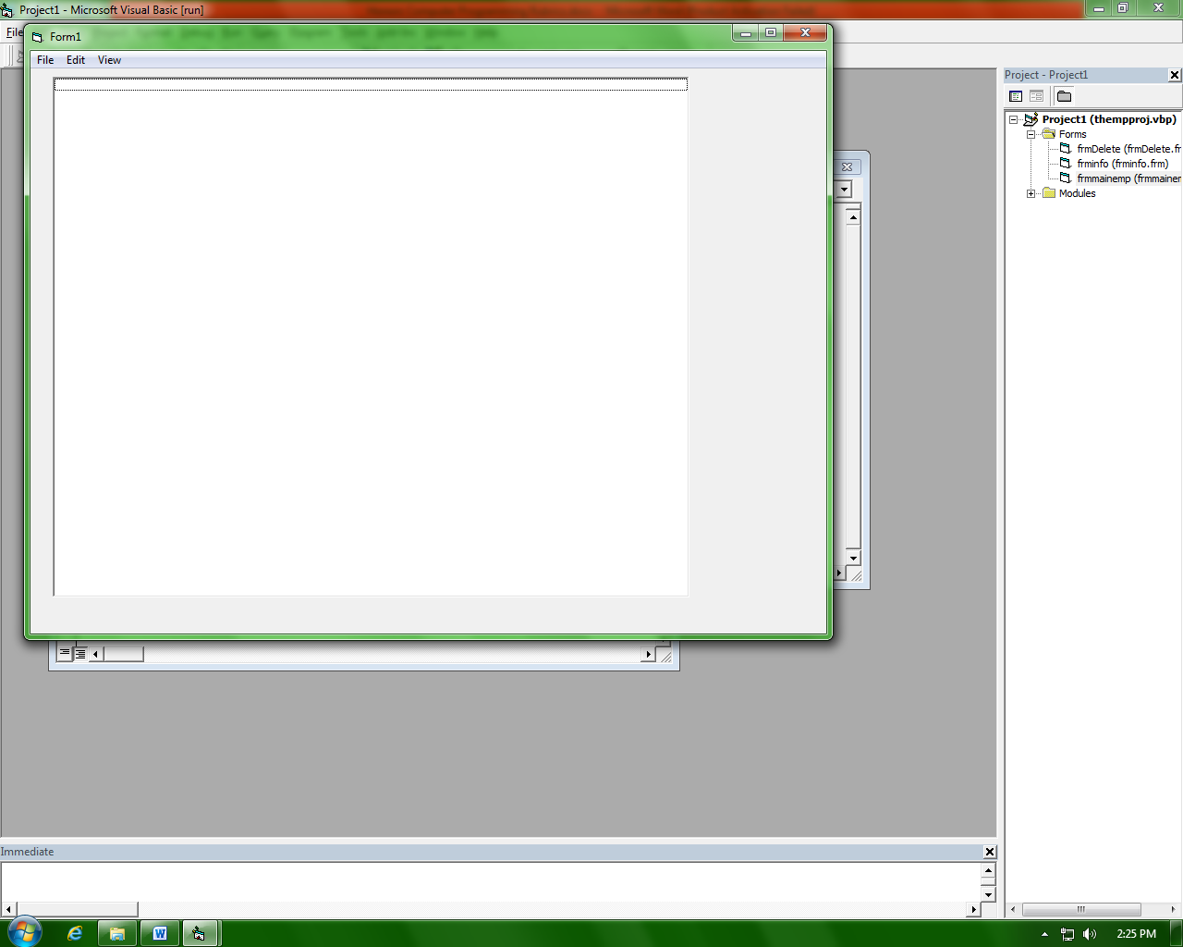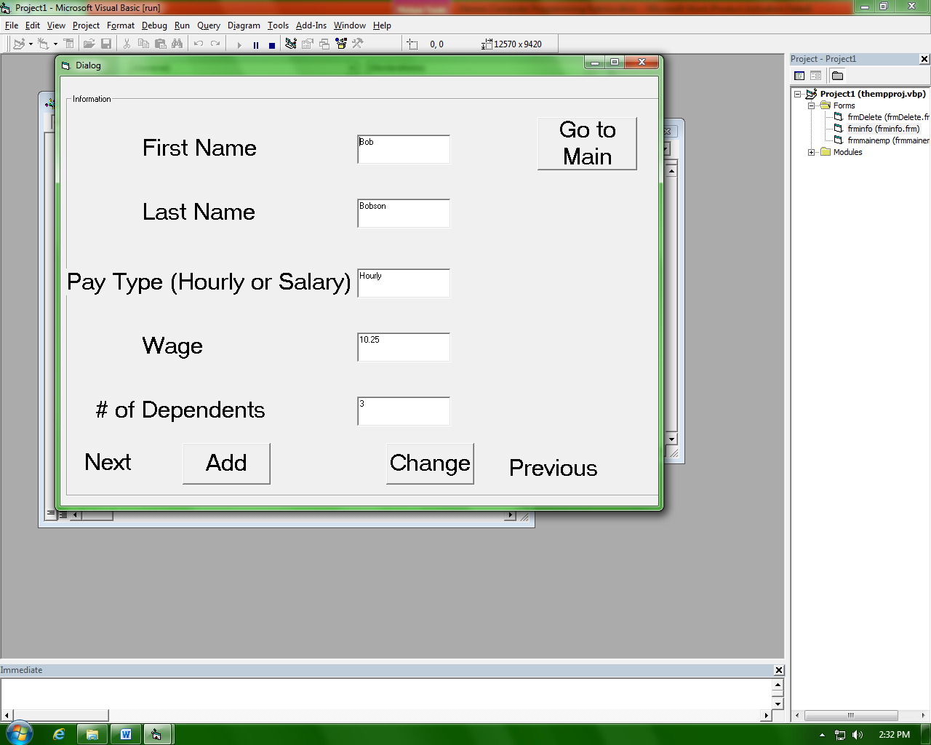

**Sort and Search**- Create a program that will generate a list of data, sort and display time, and search through it for an item

**“B”**

1. Create 2 random arrays (Integers and Words)

2. Generate up to 5000 pieces of data

3. Three different sorts

4. Binary Search

**“A”**

1. User-defined Data Type array

2. Uniqueness

3. Binary search to find all occurrences

4. Save and Retrieve

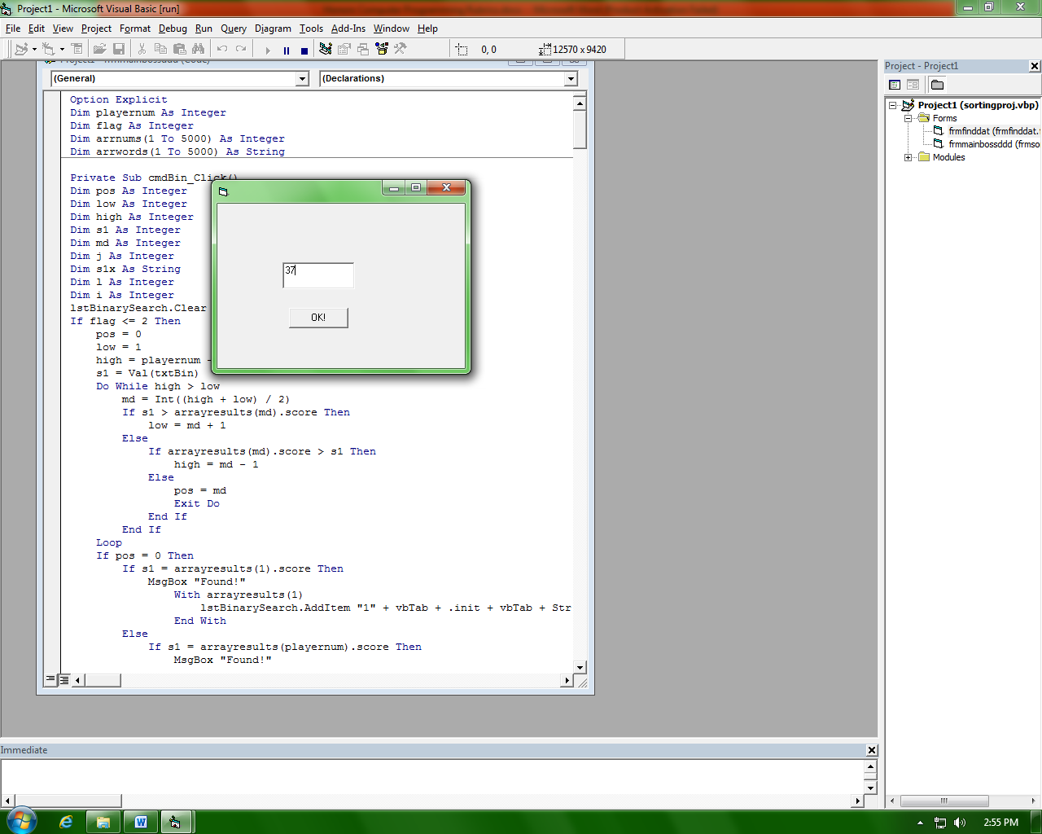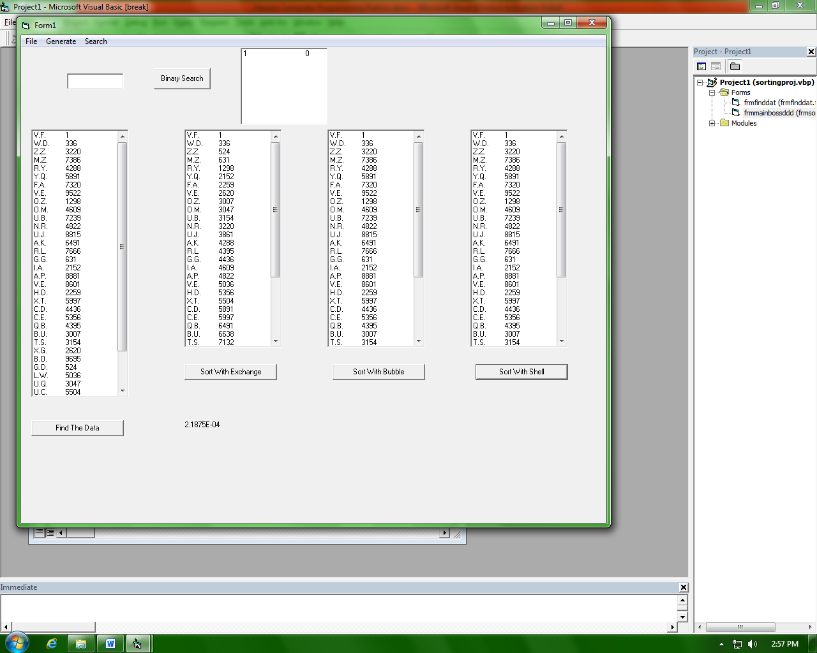

**Scrabble**- Create a game that will play Scrabble

**“B”**

1. Bag of tiles (Data read from .txt using Mid() to fill up UDT tile)
2. 7 unique tiles
3. Play Scrabble
4. Make a word
5. Score

**“A”**

1. Replacement with Uniqueness(2)
2. Blanks
3. Top Ten(UDT array)

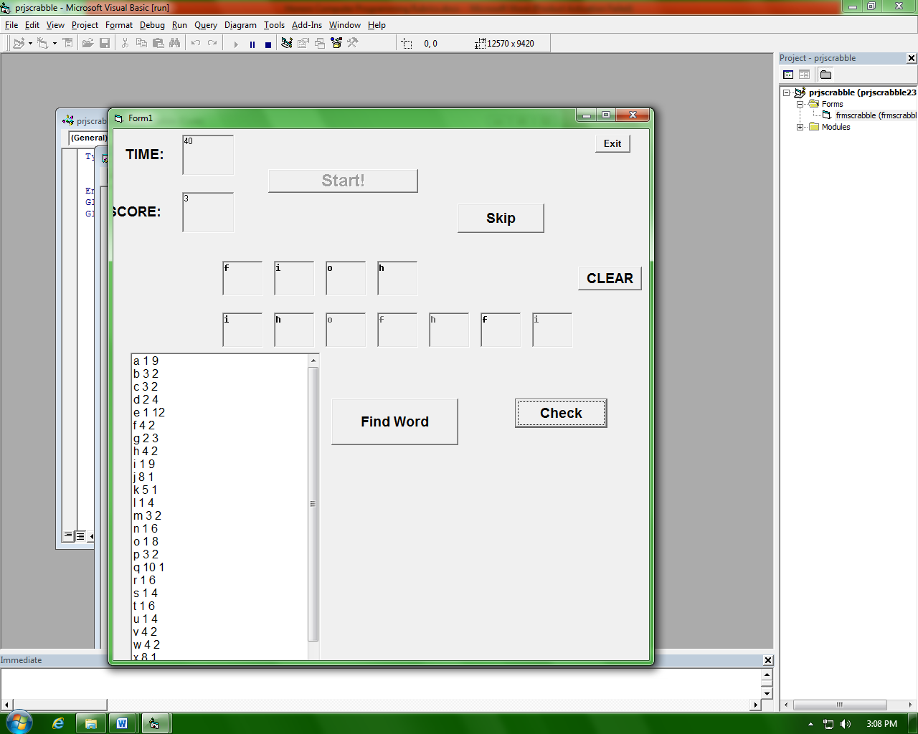

**VB.NET Projects**

**Compression/Decompression**- Create a program that will allow the user to choose options for a product, compress the results into an identification number, save an array of these id’s as a file, then retrieve the file, fill up the array of id’s and decompress the identification number into the products

**“B”**

1. 3 radio buttons * 3

2. 3 combo boxes*3

3. 8 check boxes

4. Compress

5. Add

6. Save and retrieve

7. Decompress

**“A”**

1. More data (1 more combo, 1 more radio, and 4 more check)

2. Change

3. Delete

4.Multimedia (Pictures, Sound, Animation)

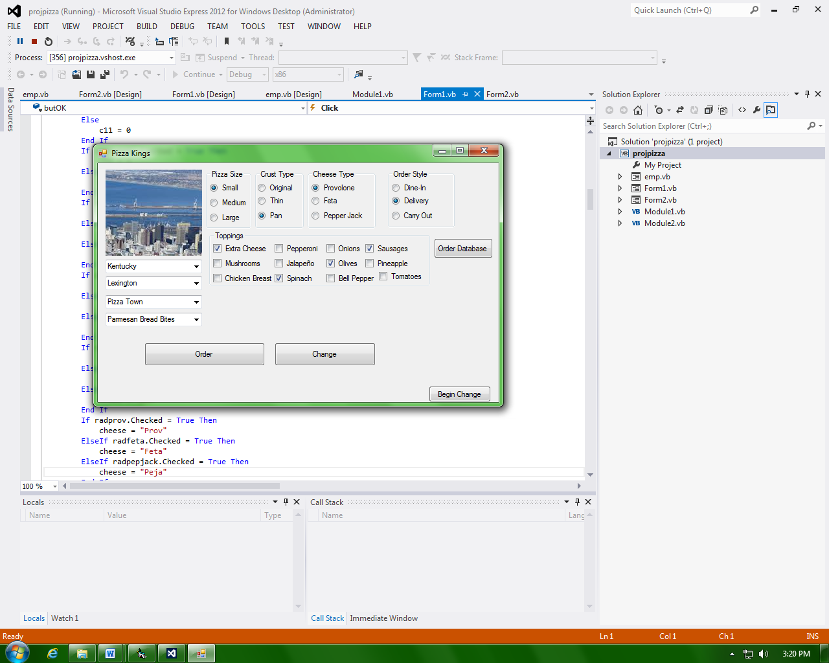

**Card Game**- Create a program that will play a card game

**“B”**

1. Shuffled Deck of Cards(UDT and uniqueness)
2. Display image of cards(Image.fromFile(“H:\cardimages\”+cstr+”.gif”)
3. Score
4. Play Game (high card)

**“A”**

1. Better game (Black Jack)
2. Top Ten

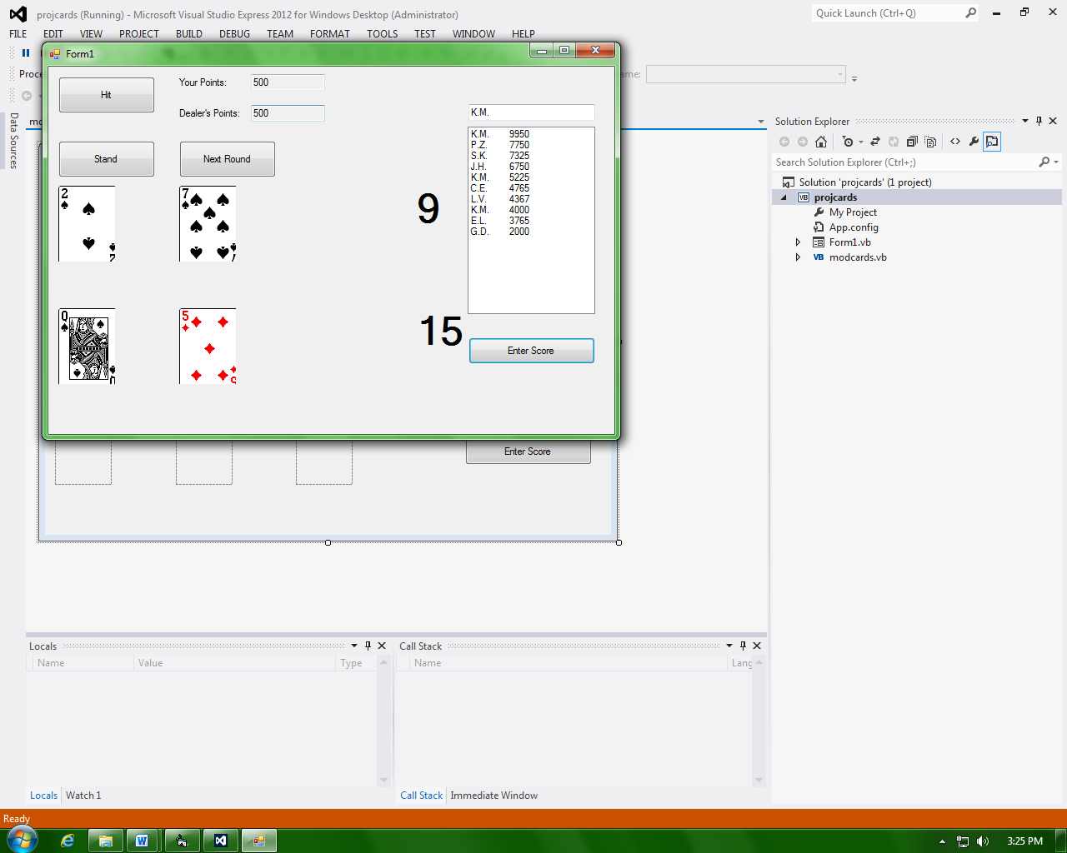

**Animation**-

**“B”**

1. Motion
2. Collision
3. User interface
4. Score
5. Top Ten

**“A”**

1. Structure and functionality
2. Better motions
3. Better collision
4. Graphics
5. Better user interface

